CAUTION :To avoid damage to hearing DO NOT PLACE TRANSMITTER CLOSE TO EAR

The Speed of Sound in Air

Introduction
In this experiment the speed of sound in air is to be obtained, by pulse-echo timing, with an accuracy of at least 1 part in 10⁴ ((a few) parts in 10⁵ is attainable). This value should then be compared with the theoretical value, whose derivation is discussed below.

Theory of the speed of sound in air
The speed of sound c in a gas of density p is given by

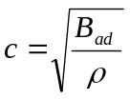,

where B_{ad}. is the adiabatic bulk modulus (or 'elasticity') of the gas, and ρ is a measure of its 'inertia'. For a gas whose mean pressure is P [Pa],

B_{ad}. = γP, (2)

where γ is the ratio of the principal specific heats of the gas (= C_{P}/C_{V}), C_{P} and C_{V} being
the heat capacities of 1 mol. of gas (say) at constant Pressure and constant Volume, respectively.

The value of γ

For a monatomic gas (such as Helium, or Argon) the 3 degrees of molecular translational freedom lead to a specific heat at constant volume of C_{V} = 3R/2, where R is the Gas
Constant (= 831432 J K^{-l} mol^{.-1}), the heat energy being stored as kinetic energy of the
gas molecules. Also, from consideration of the work done in heating any gas at constant
pressure, C_{P} = Cv + R. Thus, γ =5/3 for monatomic gases.

For diatomic gases, on the other hand, such as Nitrogen, N₂ or Oxygen, 0₂, there are two
Additional ( rotational ) degrees of freedom for energy storage in the gas, leading to a
Specific heat at constant volume of Cv = 5R/2,and therefore a value of γ =7/5 for
diatomic gases.

For a mixture of gases the net value of γ is the average value as calculated from the
Individual values of γ for each species of gas present in the mixture, weighted by their
Relative number densities, i.e. fractions of the total molecular number 1 mol of gas.

CAUTION :To avoid damage to hearing DO NOT PLACE TRANSMITTER CLOSE TO EAR

The speed of sound as a function of the temperature, T.
Equations (1) and (2) allow the speed of sound to be written

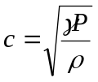 (3)

and since the pressure P and density p of the gas are proportional to one another, it is seen
that the speed of sound is pressure independent (this rule breaks down at very low and
very high gas pressures).

However, the ratio P/ρ does depend upon the absolute temperature T [K], and for 1 mol.
of gas the ideal gas equation can be written PV = RT, so that

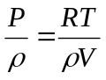 ( for 1mol. )

But, ρV is the molar mass of the gas, m (say). Therefore equation (3) can be written ,

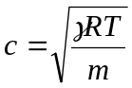 [m.s⁻¹ ], (4)

where it is seen that for a given gas, or gas mixture, where both γ and m are fixed, the
speed of sound c depends only on the temperature T⎯as 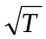

In the case of a gas mixture m, like γ , is the average value for the molecular species in the
Mixture. This is calculated from the individual molar masse weighted by their respective
Proportional number densities, i.e., by their fractional abundance in the mixture.

Dry Air
For dry air the major constituents are ( by fractional molecular abundance ) :-

gas | ( % ) in air | molar mass ( g ) | γ
Nitrogen | 78.08 | 28.013 | 1.404
Oxygen | 20.95 | 32.000 | 1.401
Argon | 0.93 | 39.948 | 1.668
CO₂ | 0.03 | 44.000 | 1.304

Humid Air
However, water vapour in the air adds another, variable, constituent to the air. displacing
these other molecular species from the 1 mol. of air under consideration (the other species
nevertheless maintaining. their same relative abundance to each other).

CAUTION :To avoid damage to hearing DO NOT PLACE TRANSMITTER CLOSE TO EAR

Now, the number density of water molecules depends on the relative humidity (RH) of the
air, this quantity being defined as

RH = quantity of water vapour present = pressure of water vapour
Quantity which would saturate at saturation pressure ( T )
ambient temperature

this ratio normally being expressed as a percentage: RH [ % }. And the saturated vapour
pressure of the air depends on the ambient temperature T [ K 1. Table 1 below gives
the saturated pressure of the water vapour in mm of Hg for temperatures between
T = 150C and T = 300C, in steps of 0.20C.

Example: It is seen, for example, that at T 25'C the saturated vapour pressure of water is
23.756mm of Hg. Therefore, for a PH value of 60%., say, the vapour pressure of water in
the air would be 0.6 x 23.756 = 14.254mm of Hg. If the ambient air pressure-as read
from a barometer-were 76Omm of Hg at that time, say, then water molecules would
constitute (by fractional number density)
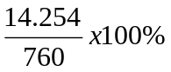

or 1.88% of the humid air (since the vapour pressure is proportional to the molecular
number density of each molecular species in the air, for a given temperature). In this
example 14.254mm is the 'partial pressure' of water molecules in the air. The remaining
745.75mm of Hg here is due to the partial pressures of the dry air constituents listed
above, which are still present in their given, respective, relative ratios.

Thus it is seen that in this example water vapour is the third largest constituent of the air,
after Nitrogen and Oxygen, and it therefore must be included in the calculation of the
mean values of both γ, and the mean molar mass, m. Note that For water vapour

gas (%) in air molar mass (g) γ

H₂0 variable- 18.000 1.31
depends on
T and RH.

Table.l: Saturated vapour pressure of water (mm of Hg)

T [^{O}C] | 0.0 | 0.2 | 0.4 | 0.6 | 0.8
15 | 12.788 | 12.953 | 13.121 | 13.290 | 13.461
16 | 13.634 | 13.809 | 13.987 | 14.166 | 14.347
17 | 14.530 | 14.715 | 14.903 | 15.092 | 15.284
18 | 15.477 | 15.673 | 15.871 | 16.071 | 16.272
19 | 16.477 | 16.685 | 16.894 | 17.105 | 17.319
20 | 17.353 | 17.753 | 17.974 | 18.197 | 18.422
21 | 18.650 | 18.880 | 19.113 | 19.349 | 19.587
22 | 19.827 | 20.070 | 20.316 | 20.565 | 20.815
23 | 21.068 | 21.324 | 21.583 | 21.845 | 22.110
24 | 22.377 | 22.648 | 22.922 | 23.198 | 23.476
25 | 23.756 | 24.039 | 24.326 | 24.617 | 24.912

CAUTION :To avoid damage to hearing DO NOT PLACE TRANSMITTER CLOSE TO EAR

Table.1 (cont'd): Saturated vapour pressure of water (mm of Hg)

T (^{O}C ) | 0.0 | 0.2 | 0.4 | 0.6 | 0.8
26 | 25.209 | 25.509 | 25.812 | 26.117 | 26.426
27 | 26.739 | 27.055 | 27.374 | 27.696 | 28.021
28 | 28.348 | 28.680 | 29.015 | 29.354 | 29.697
29 | 30.043 | 30.392 | 30.745 | 31.102 | 31.461
30 | 31.824 | 32.191 | 32.561 | 32.934 | 33.312

Therefore, the temperature T [K], the relative humidity RH [% , and the barometric .
pressure P [mm of Hg, here] need to be measured in order to calculate the theoretical
value of the speed of sound in air, c.

Experimental method

Foreword: the pulse-echo experimental technique.

The experimental method employed here depends on measuring. the round-trip pulse-to
echo 'flight-time' t of an ultrasonic pulse. The pulse is -generated by a 6OkHz high~power
acoustic transmitter, and it is reflected by a plane target reflector some distance x away.
The reflected echo travels back to the transmitter-which has meanwhile turned itself into
a microphone (as discussed below)-where it is detected, the ultrasonic pulse having
traversed a path-distance 2x.

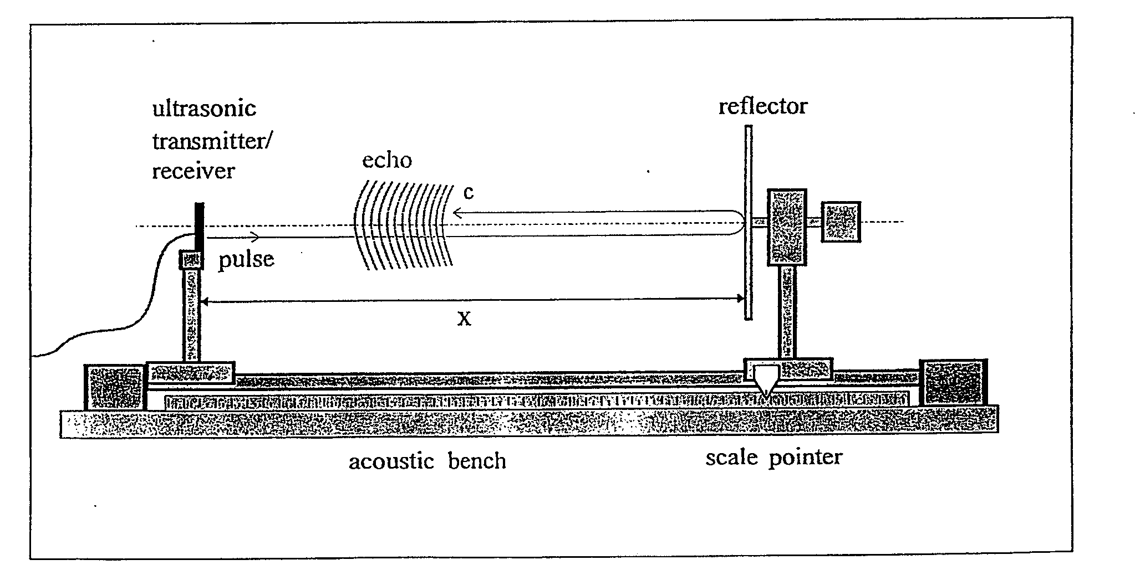
However , in order to make an accurate measurement of the speed of sound it is necessary
To reduce potential sources of error⎯both systematic and random⎯to a minimum

CAUTION :To avoid damage to hearing DO NOT PLACE TRANSMITTER CLOSE TO EAR
S ystematic error

The experiment consists of making measurements of the flight time t against the flight Path length
2x. But as the exact distance x is difficult to measure with sufficient accuracy (±0. 1 mm accuracy
would be necessary for 1 part in 1 0⁴, it is the rate of change of pulse flight-time t with distance
2x that is actually measured here-the inverse of this quantity being the required speed of sound in
air, c. Therefore, with this approach, neither the absolute value of the actual flight-path distance 2x,
nor the absolute value of the flight-time t, need be known, and the 'distance' 2x, for example, can be
read directly from (twice) the scale-pointer reading. Note that on the acoustic bench the scale-pointer
does not line-up with the position of the reflector-nor does the zero of the x-scale line-up with the
transmitter position. Neither is necessary here.

The reflector position needs to be read to an accuracy of ±0. 1 mm. Note that the quartz-crystal
controlled measurement timebase can be taken as having an accuracy of ± 1 0 ppm.

For the purposes of comparing the theoretical value with the experimental result for the speed of sound
in air, it will be necessary to measure the relative humidity of the air using, the 'whirling psychrometer'
provided or the digital temp/humidity meter. A measurement at the beginning and a second measurement at the end of the experiment is sufficient. The 'wet bulb' depression can be used together with the table in Appendix A to extract the relative humidity in %. The mean ambient air pressure needs to be measured only once during- the course of experiment-a barometer may be found in the Honours Lab., room 5: 07.

Random errors

By using the pulse-echo method of measurement one potential source of random error that due to
slowly-moving currents of air in the laboratory-is minimised. Thus, any air currents having resolved
components along the measurement direction, adding (say) to the velocity of the outgoing pulse, will
retard, equally, the returning echo, making the measurement insensitive to such first order potential
sources of error. Any cross-track air currents would induce very much smaller second-order errors.

However, from equation (4) above the speed of sound c is proportional to 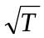,where T is the absolute temperature, and this could vary (generally increasing throughout the day) by as much as I'C during the
course of 1 hour. Therefore the ambient air temperature must be monitored continuously throughout the experiment (to an accuracy of ±0.05K), and the range~values corresponding to different reflector positions should be chosen so as to minimise the effects of temperature drift, either (i) by choosing the reflector positions completely randomly, or (ii) by choosing them in the order: long range, short range, Iong. range, short range, etc...., working, in towards the centre of the acoustic bench. In either case, clearly it is essential to carry out the experiment quickly, in order to minimise this effect. There is a trade-off that must be made between the number of flight-time measurements to be made at each distance, and the number of reflector positions to be used. You should aim for at least 50 reflector positions.

CAUTION :To avoid damage to hearing DO NOT PLACE TRANSMITTER CLOSE TO EAR

Apparatus.
Connection to a computer

The experimental apparatus can be controlled by any PC (or Apple Mac) over a serial communications
line connected to the 'Speed of Sound Interface' unit. Ensure that the appropriate Communications port (e.g. COMI) on the computer is activated for serial communications. The data rate to be selected is 9600 baud, with a word structure of. No parity, 8 data bits, and 1 stop bit.
Only a small number of simple controlling commands are necessary, as explained below, because the
'intelligence' needed to control the measuring apparatus is actually contained within the
'Speed of Sound Interface', rather than in the PC itself Thus the PC is free, potentially, to carry out other
tasks, such as semi-automatic overall control of the experiment, data-handling, graph-plotting, etc.
(a 'bespoke' computer program would have to be written to accomplish this); or, the experiment can be run simply from any Terminal emulating program running, on the PC.

Speed of Sound Interface

The 'Speed of Sound Interface', shown schematically in the diagram below, contains the electronics to drive the ultrasonic transducer, as well as housing a small stand-alone microcontroller board to which this electronics has been interfaced.

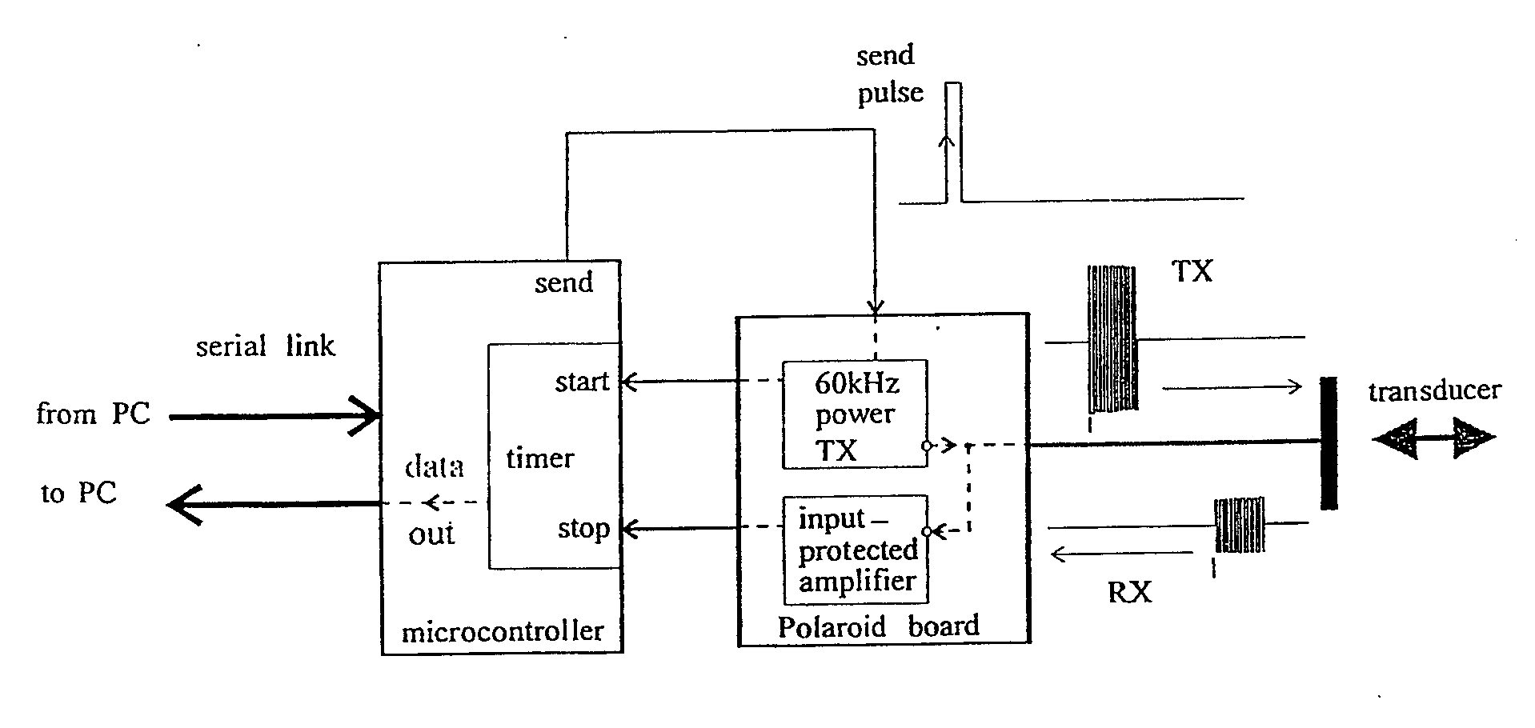

The microcontroller has been pre-programmed (in the language 'C'-using a crosscompiler) to carry out the dedicated low-level task of initiating and measuring, on command, the pulse time-of-flight, t. It may also carry out, on command, some statistical data-reduction on repeated flight-time measurements, if required. The 'Speed of Sound Interface' therefore communicates bidirectionally with the controlling computer: it interprets and carries out Incoming instructions to make one, or more, flight-time measurements, t; and it sends the measured values of t back over the serial link to the controlling computer.

CAUTION :To avoid damage to hearing DO NOT PLACE TRANSMITTER CLOSE TO EAR

Speed of Sound Interface Controlling Instructions.

mn (or Mn) (return) 'Measure'...
make n flight-time measurements, t, where 1 < n < 1 00, returning n measurements of t in microseconds, the data being sent in tabulated format, 1 0 values per line.

e.g. ml (return) make 1 measurement, or
m20 (return) make 20 measurements.

an (or An) (return) 'Average'...

make n flight-time measurements, t, where 1 < n < 1 00, returning a single
average value of t in microseconds, over the n measurements. The data are returned in the format

5004.56 microseconds

e.g. a40 (return) average 40 measurements.

en (or En) (return) 'average with standard Error'...
make n flight-time measurements, t, where 1 < n < 1 00, returning a single
average value of t, along with the standard error in t, taken over the n
measurements. The data are returned in the format

5004.56 +/- 0.45 microseconds

e.g. e100 (return)...

... find average and standard deviation of 1 00 measurements.

The Ultrasonic Transducer.

The ultrasonic transducer and its associated electronics are taken from a PolaroidTM autofocus camera. When operated as a 'transmitter' the transducer is driven by a 1ms long, 6OkHz, 30OV peak-peak signal, which vibrates a stretched gold-coated polymer diaphragm. This diaphragm forms one plate of a capacitor inside the transmitter's housing, and grooves in the rigid backing-plate of the capacitor form an air 'spring' so that the mass of the polymer diaphragm is driven into resonance by the oscillating voltage. Thus the oscillating diaphragm generates 6OkHz ultrasound, the major part of this acoustic power actually being radiated into a forward-cone of half-angle approximately 15º.

CAUTION :To avoid damage to hearing DO NOT PLACE TRANSMITTER CLOSE TO EAR

To the ear the transmitter makes a quiet 'tick', because we can only hear the envelope of the 6OkHz ultrasound
pulse (strictly-speaking, 'tone-burst'); but if the car were to be placed up against the transmitter for a prolonged period of time then the high instantaneous acoustic power level could nevertheless cause damage to your hearing.: DO NOT ATTEMPT THIS!!

However, since the acoustic energy from the transducer is directed into a narrow-angle forward cone, no
special measures need be taken when working at the side of the acoustic bench with the transmitter running.

In operation the 6OkHz, 30OV peak-peak, drive-signal to the transducer is rectified by diodes, leaving the transducer electrically charged at the end of each transmitted ac pulse.

.So, once the vibrations of the transmitting diaphragm have died away, following the transmitted pulse, the transducer is left with a static charge-just as in an electret microphone transducer. Subsequent vibrations of
the ( now charged ) diaphragm - due to incoming ultrasonic 'echo'- therefore induce a small voltage signal
across the transducer This 'echo' signal is amplified, and used to stop the timer.

METHOD

The aims of this experiment are twofold: firstly to measure the speed of sound in air, c, to high accuracy;
and secondly, to compare this value with the theoretical result. So, as explained above, you must (i) keep a continuous record of the ambient air temperature throughout the experiment, using the thermometer provided (to +0.05'C), (ii) measure the relative humidity of the air at the beginning and end of the experiment, with the psychrometer provided (to +5%RH), and (iii) measure (once) the current air pressure using the lab. barometer (to +1 mm of Hg). Naturally, you cannot extend the measurement part of this experiment over more than one day.

In parallel with these physical measurements you may control the Speed of Sound in Air experiment using the PUTTY Terminal Emulator.

The PUTTY Terminal Emulator

The simplest (if not the most versatile) way to control the Speed of Sound experiment is to use the PUTTY terminal emulator. Click on the Putty icon on the desktop , select serial then open.

Once the terminal emulator is running, switch-on the Speed of Sound Interface unit, and a 'Speed of Sound...' heading should appear on the screen, indicating that communication has been established with the Speed of Sound Interface unit. If the Speed of Sound Interface unit was already switched on then press its 'RESET' button to achieve the same effect. The unit will now respond to the control menu inputs listed above:-

e.g., type m1 ( return ), to charge the ultrasonic transducer.

CAUTION :To avoid damage to hearing DO NOT PLACE TRANSMITTER CLOSE TO EAR

To save data, highlight the data you wish to save then right click on the top toolbar and select ‘copy all data to clipboard ‘

You can now make your time measurements t at each reflector position (distance x).

Document each reflector position with, for example

d= 405.5mm e50 <return>
current make 50 measurements,
reflector returning average +
position standard error of flight - times

N.B. You must keep an accurate record of the reflector distances x at which you take your measurements.

You are strongly advised to carry out a rough sequence of measurements first of all over the widest possible range of reflector positions. You will see that at small distances x the flight-times t saturate at
an essentially constant value--since the ultrasonic transducer has not yet changed over from 'transmit' to 'receive' mode (it is waiting for the 'transmit' oscillations of its diaphragm to die away before it can listen for the detected echo). So there is a 'dead-patch' on the acoustic bench over which meaningful measurements cannot be made. You must first of all establish its extent before passing on to second 'high-accuracy' measurement phase of the experiment-to be made over the 'linear' region of the acoustic bench.

CAUTION :To avoid damage to hearing DO NOT PLACE TRANSMITTER CLOSE TO EAR

AppendixA: Relative Humidity 'wet-bulb depression ' data.
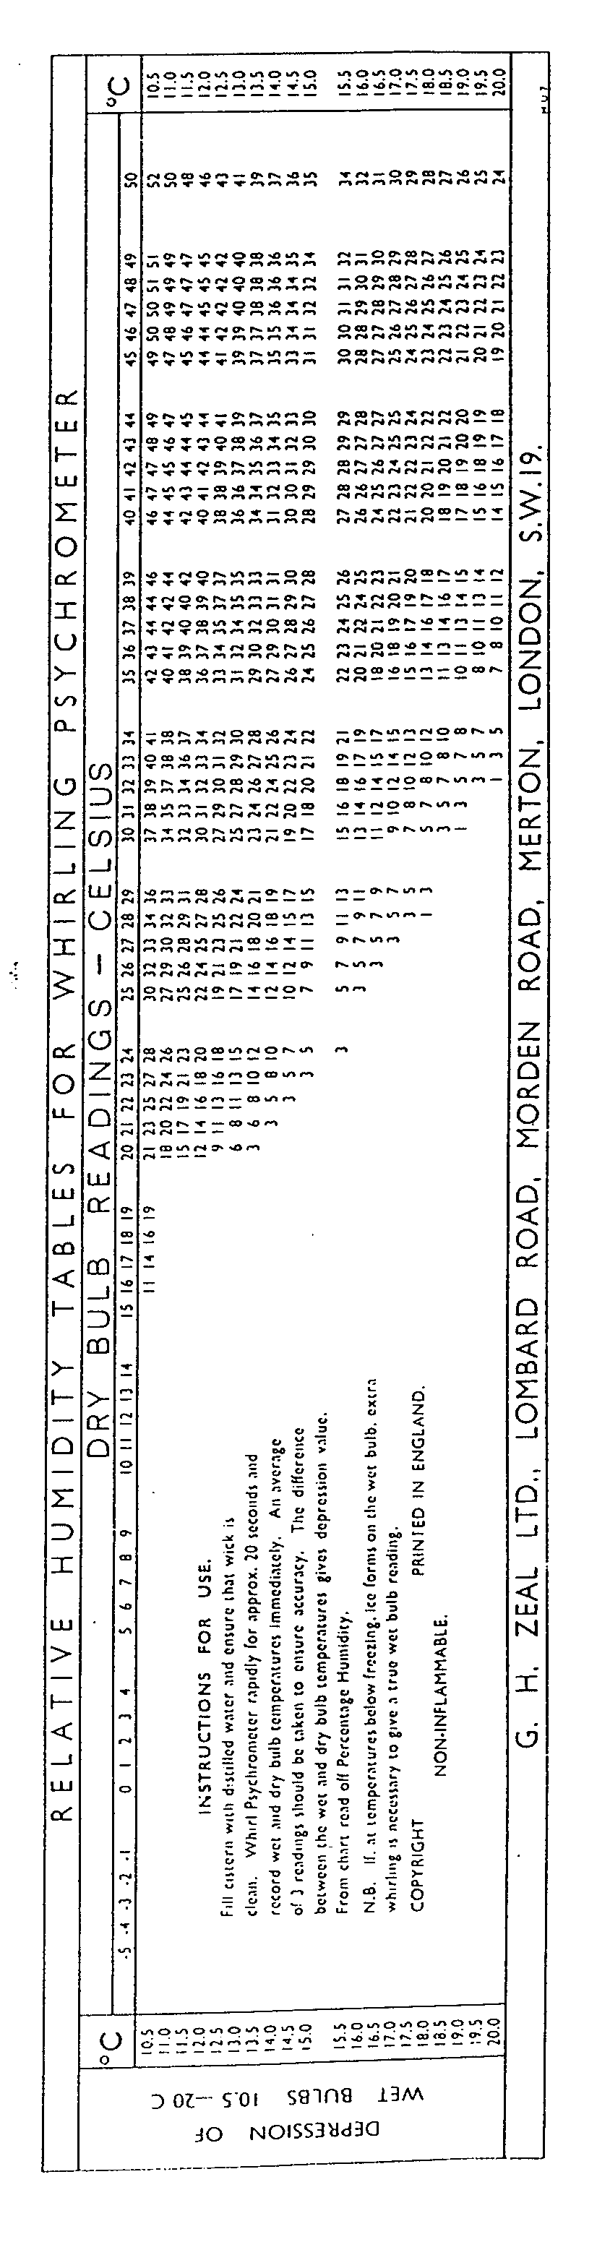
CAUTION :To avoid damage to hearing DO NOT PLACE TRANSMITTER CLOSE TO EAR
